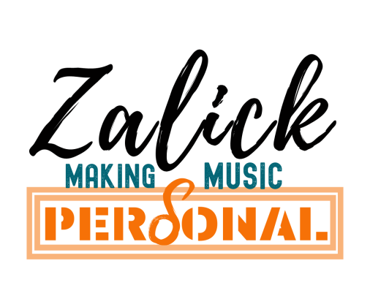
Dear Parent/Guardian,
Singing and Vocal Performance

Zoe Zalick MA, Music Psychology,
Bed. (Hons) with QTS,
Founder of Own Your Voice community
Website: zalick.co.uk
Email zoe@zalick.co.uk

I am pleased to be offering singing lessons and performance coaching at your child’s school in the current academic year.
The voice is the most expressive and flexible instrument of them all and lessons benefit any student wishing to pursue musical or theatrical performance at or beyond school. Good singing can also improve confidence and contribute to higher self-esteem and better physical fitness. My lessons focus very much on the needs and interests of the pupils involved and I select material of the right level that I know will be enjoyed. As with other instruments, graded examinations can be taken in singing and I can prepare pupils for these if required. Grade 5 is regarded as equivalent to GCSE level and can be a valuable addition to a student’s profile. Higher grades are worth UCAS points. Pupils can specialise in popular styles, musical theatre or classical singing. Many choose to work towards auditions, competitions and/or public performances.
Singing lessons will take place during the school day on a rotating timetable and last for 20-30 minutes, depending on type. Some break, lunch or after school times may be available. There will be ten lessons in every term. Fees will be requested at the beginning of each term and you may arrange to pay in instalments if you wish. Subsidies are available for those in receipt of free school meals. For dedicated vocal performers, 30 minute individual lessons are best. For students new to singing, 20 minute individual or shared lessons are a good option
If you would like your daughter/son to receive lessons, please fill out the google form on this link https://forms.gle/URZ1n3Y6TxWy6msv6 or fully complete the form below and return to the school office. Should there be unforeseen school closures, online lessons will be offered. Please do contact me with any questions on zoe@zalick.co,uk
Many Thanks,
Zoe Zalick (Mrs)
.
.................................................................................................................................................................................................................................

To Mrs Zalick (Singing Teacher) Date ................................................................................................................
PRIVACY POLICY: Your details will only be used to contact you and will not be shared with anyone else unless you give consent to do so.

Name of pupil ……………………..................................... Date of birth........................

Address……………………………………………………………………………………………………....................................

School ..................................Form/ Year group...................... Previous experience or SEND?.....................................

Name of parent/guardian ……............................................................Name of bill payer.....................................

Electronic contact details: ....................................................................................................................................

Comments or requests……………………………………………………………………………………...........................................................

I wish my daughter/son to begin (please indicate your choice):

30 minute Individual lessons @ £13.50 per lesson 30 minute shared lessons (2-3pupils) @ £7.00 per lesson

20 minute individual lessons @ £7.00 per lesson

I will pay lesson fees upon request Signed: .................................................................................................

I am in receipt of free school meals and would like to apply for subsidised music lessons. I give permission for my details to be shared with Cornwall Music Education Hub

signed...............................................................................................................

