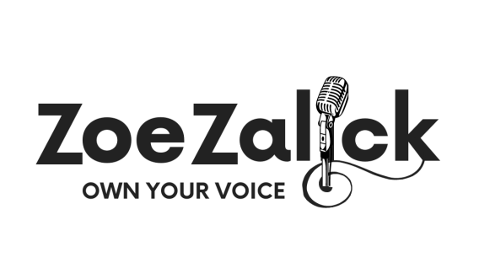 Dear Parent/Guardian,
School year 2023-2024
Singing and Performance
Zoe Zalick MA, Music Psychology,
Bed. (Hons) with QTS,
Website: zalick.co.uk
Email zzalick@hotmail.com

I am pleased to be offering singing lessons and performance coaching at your child’s school.
The voice is the most expressive and flexible instrument of them all and lessons benefit any student wishing to pursue musical or theatrical performance at or beyond school. Good singing can also improve confidence and contribute to higher self-esteem and better physical fitness. My lessons focus very much on the needs and interests of the pupils involved and I select material of the right level that I know will be enjoyed. As with other instruments, graded examinations can be taken in singing and I can prepare pupils for these if required. Grade 5 is regarded as equivalent to GCSE level and can be a valuable addition to a student’s profile. Higher grades are worth UCAS points. Pupils can specialise in popular styles, musical theatre or classical singing. Many choose to work towards auditions, competitions and/or public performances.

Singing lessons will take place during the school day on a rotating timetable and last for 15-30 minutes, depending on type. Some break, lunch or after school times may be available. There will be ten lessons in every term. Fees will be requested at the beginning of each term and you may arrange to pay in instalments if you wish. Subsidies are available for those in receipt of free school meals. For dedicated vocal performers 30 minute individual lessons are best. I also offer an online practice portal for feedback and support through holidays and between lessons. Please email me if you would like more information about this or anything else.

If you would like your daughter/son to receive lessons, please fill out the form on the Google link below or complete and return the slip below to the school office.
Many Thanks,
Zoe Zalick (Mrs)
. Google form: https://forms.gle/teSpKbtz4xfK3cAu7

............................................................................................................

To Mrs Zalick (Singing Teacher) Date ................................................................................................................
PRIVACY POLICY: Your details will only be used to contact you and will not be shared with anyone else unless you give consent to do so.

Name of pupil ……………………..................................... Date of birth........................

Address……………………………………………………………………………………………………....................................

School ..................................Form/ Year group...................... Previous experience or SEND?.....................................

Name of parent/guardian ……............................................................Name of bill payer.....................................

Electronic contact details: ....................................................................................................................................

Comments or requests……………………………………………………………………………………...........................................................

I wish my daughter/son to begin (please indicate your choice):

30 minute Individual lessons @ £170 whole term 30 minute shared lessons (2-3pupils) @ £90 whole term

15 minute individual lessons @ £90 whole term Individual lessons in school + online support @ £50 per MONTH

I will pay lesson fees upon request Signed: .................................................................................................

I am in receipt of free school meals and would like to apply for subsidised music lessons. I give permission for my details to be shared with the music subsidy administration body, ASONE

signed...............................................................................................................

